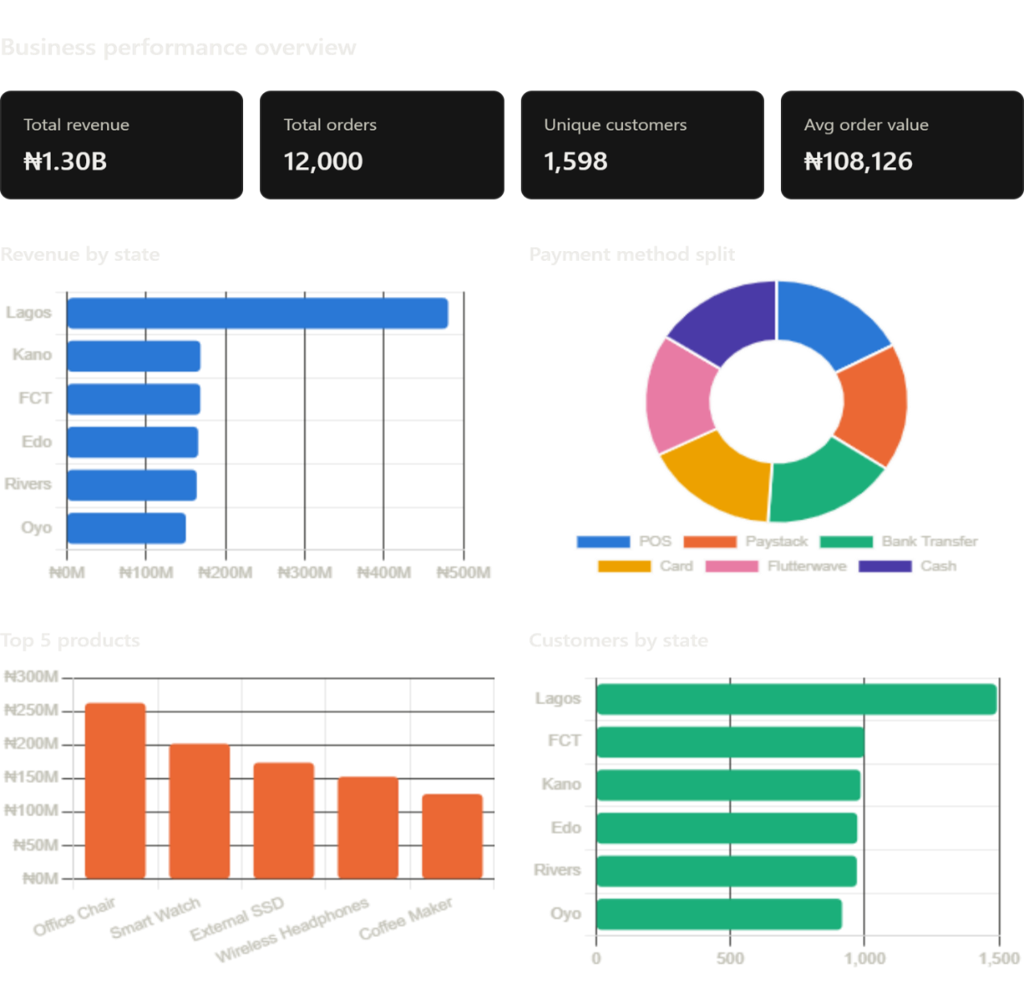

1. Data Quality Blocker: ₦10.7M From Unidentified Customers
0.8% of revenue (₦10.7M) is tied to NULL customer IDs, preventing RFM analysis, personalization, and repeat-purchase insight on a non-trivial revenue slice. Your top single customer (CUST1824) generates only ₦3.3M—suggesting your named customer database is incomplete or your checkout flow has friction.

2. Product Revenue Concentration
Your top 5 products generate ₦891M (69% of revenue), with Office Chair alone accounting for ₦262M (20%). Smart Watch and External SSD are the only other significant contributors. The remaining thousands of SKUs are breadth with low impact.

3. Category Performance Mismatch
Electronics (8,086 qty) drives 37% of unit volume but the top product (Office Chair—hard furniture, not electronics) dominates revenue. Fashion and Home are quantity-competitive with Electronics but likely lower AOV. The data suggests you're selling high-volume, low-ticket items in Electronics/Fashion and low-volume, high-ticket items in furniture—creating operational complexity (SKU proliferation, warehouse space, returns handling).

4. Customer Density vs. Revenue Density
1,598 customers generating ₦1.3B = ₦812K per customer on average. With 12,000 orders, that's ~7.5 orders per customer. These are likely repeat buyers or high-ticket purchases—both valuable. However, the skew (top customer ₦3.3M, median likely <₦500K) suggests a heavy long tail you're not extracting value from.

5. Critical Geographic Concentration Risk
Lagos represents 37% of total revenue (₦481M from ₦1.3B) with only 93% of your customer base, indicating extremely efficient monetization in that region. However, this heavy dependence creates supply-chain and demand risk. The remaining five states each contribute 12-13% of revenue despite comparable customer counts to Lagos, suggesting significant untapped efficiency in Kano, FCT, Edo, Rivers, and Oyo — or potential pricing/positioning misalignment.

6. Payment Method Balance (Good News)
Revenue is nearly perfectly split across POS, Paystack, Bank Transfer, Card, Flutterwave, and Cash (each 16–17%). This resilience means a single payment processor outage has minimal impact, and you're not over-dependent on one payment rail. The balance also suggests you serve diverse customer segments (cash, mobile, traditional banking).

Summary & Next Steps
Issue # | Priority | Finding | Impact | Timeframe
1 | High | Fix customer ID capture (₦10.7M untagged) | Unlock customer analytics, retention modeling | 1–2 weeks
2 | High | Investigate Lagos efficiency vs. underperforming states | Potential ₦50-100M uplift | 2–4 weeks
3 | Medium | Analyze Office Chair margin & supply | Protect profit engine or rebalance SKU investment | 2–3 weeks
4 | Medium | Segment customers by LTV and build retention program | Reduce churn rate, increase repeat rate | 3–4 weeks
5 | Low | Optimize category mix and payment incentives | Margin improvement in existing volume | 4+ week

